Title: **SDA-final project**

Group members: **Zohaib Hassan Soomro, Syed Ahmed**

**Shah,**

RollNo#: **19SW42,19SW44**

Subject: **Software Design and Architecture**



**Problem Statement:**

Old system of saving data about students presented too much hassle, the manual labor was too much and the database hard-copies were hard to manage and find, furthermore they were not secure as anyone could take a peek at them.

**Solution:**

A digital system of saving student data in a database which is secure,

through a software which provides a graphical user interface which makes it easy to use and manage.

**Description:**

A GUI screen is developed for registration of new students using java swing library with sufficient data including student’s name, roll number, email and phone number to be entered by the student.

The data is also validated by this screen by using appropriate validation process. Finally, the submitted data is stored on the access database with name ‘Students.accdb’.

**Class Diagram:**

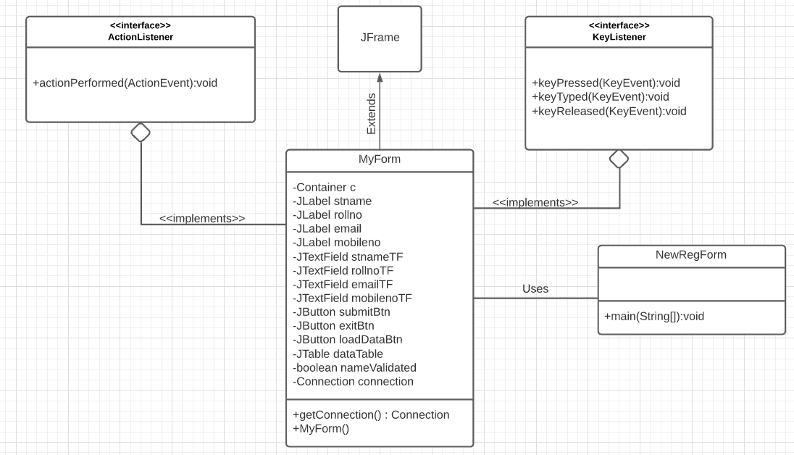

**Use Case Diagram:**

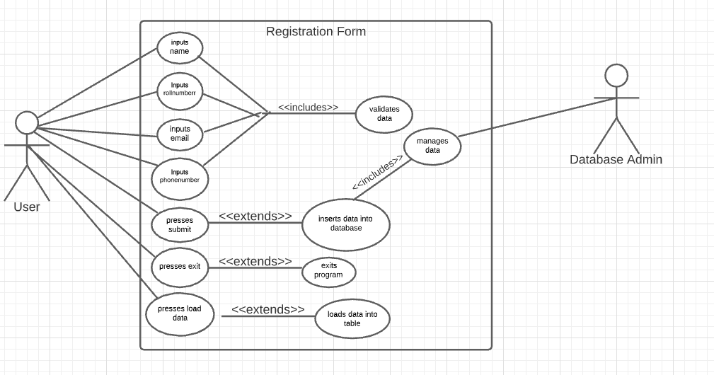

Data(current) in Database:

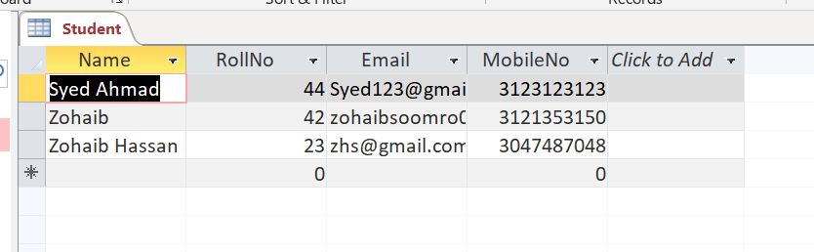

Inserting Data into Database:

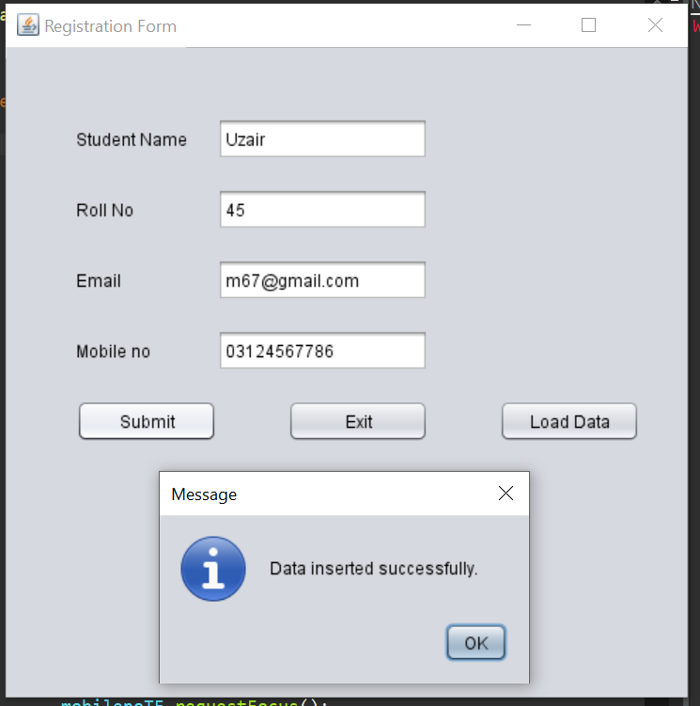

Data Loading into Table:

